**LPU – Object Oriented Programming using C++ - Internship**

**A Summer Internship Report**

*Submitted By*

**Anushil Sharma**

Registration Number: 11809795

in partial fulfillment of Summer Internship for the award of the degree of

**Btech. Computer Science Engineering (CSE)**

**Under the Guidance of**E - Box



**School of Computer Science and Engineering**

**Lovely Professional University**

Phagwara, Punjab

**June, 2020**

**DECLARATION**

I, Anushil Sharma, hereby declare that the work presented herein is genuine work done originally by me and has not been published or submitted elsewhere for the requirement of a degree programme. Any literature, data or works done by others and cited within this report has been given due acknowledgement and listed in the reference section.



Anushil Sharma

Registration Number: 11809795

Date: June, 2020

**ACKNOWLEDGEMENT**

A few typewritten words of thanks cannot really express the sincerity of my gratitude. But I am still trying to put into words my gratefulness towards all who have helped and encouraged me in carrying out this training/internship. This project of mine bears the imprint of many people who have an important impact on my thinking, behaviour, and acts during the course of study.

First of all we would like to take this opportunity to thank the LOVELY PROFESSIONAL UNIVERSITY for having summer training/training as a part of the Btech. CSE degree. The accomplishment of this internship/training otherwise would have been painstaking endeavour, for lack of staunch and sincere support of the Mittal School of Computer Science & Engineering, LPU. The incessant and undeterred succours extended by the members of the department facilitated the job to the great extent. If this goes unnoticed and unacknowledged it would be selfishness.

Many people have influenced the shape and content of this internship/training, and many supported me throughout.

**CERTIFICATES**

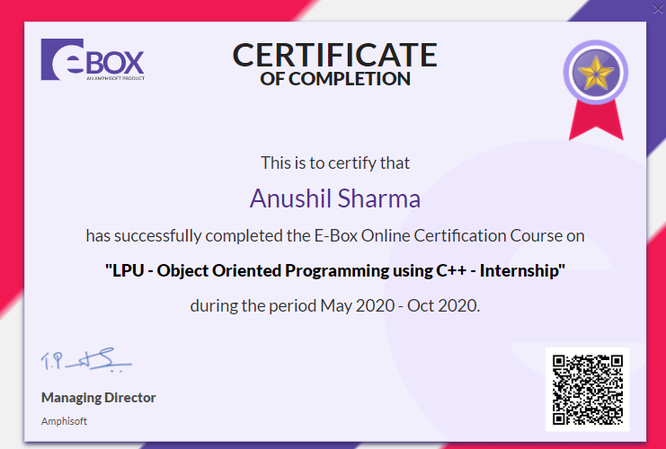

**CONTENT**

|  |  |  |
| --- | --- | --- |
| Serial No. | Title | Page No. |
| 1 | **Introduction** | **6** |
| 2 | **Code** | **7** |
| 3 | **Libraries, variables & functions used** | **8** |
| 4 | **Explanation** | **9** |
| 5 | **Procedure** | **10** |
| 6 | **Output** | **11** |
| 7 | **Learning Outcome** | **12** |
| 8 | **Reason for selecting this course** | **13** |
| 9 | **Bibliography** | **14** |

**INTRODUCTION**

I have made a project on “Face Detection” using OPENCV library for face detection.   
I have also used Visual Studio for building it up.

The code for “Face Detection” was written using the concepts of C++.

This project will detect the face in an image for which the path will be stated.  
After that it will successfully, show us an output with the recognized face on the image.

**Code for “Face Detection”**

#include<iostream>

#include<stdlib.h>

#include<opencv2\objdetect\objdetect.hpp>

#include<opencv2\imgproc\imgproc.hpp>

#include<opencv2\highgui\highgui.hpp>

using namespace std;

using namespace cv;

int main(){

CascadeClassifier faceDetection;

if (!faceDetection.load("C:\\Users\\HP\\Downloads\\opencv\\sources\\data\\haarcascades\\haarcascade_frontalface_default.xml")){

cout << "\n file is not loaded properly";

exit(0);//stdlib.h

}

char path[100];

cout << "\n Enter the path to image for face detection: ";

cin.getline(path, 100);

Mat img = imread(path, IMREAD_UNCHANGED);

if (img.empty()){

cout << "\n Image is not loaded properly";

}

else{

cout << "\n Image is found";

cout << "\n Processing";

vector<Rect> faces;

faceDetection.detectMultiScale(img, faces);//detecting here

for (int i = 0; i < faces.size(); i++){

Point pt1(faces[i].x, faces[i].y);

Point pt2((faces[i].x + faces[i].height), (faces[i].y + faces[i].width));

rectangle(img, pt1, pt2, Scalar(0, 255, 0), 2, 8, 0);

}

imwrite("C:\\as\\output.jpeg", img);

cout << "\n Face detected ok";

}

return 0;

}

**Libraries Used**

The following libraries used in my code are as follows.

* <iostream>
* <stdlib.h>
* OpenCV

**Function Used**

* Main

**Variables Used**

* path Char type
* I integer

**Explanation**

* **<iostream>**

It provides basic input and output services for C++ programs. It uses objects – cin, cout, cerr and clog for sending data to and from the standard streams imput, output, error and log respectively.

* **<stdlib.h>**

It defines several general purpose functions, including dynamic memory management, random number generation, and communication with the environment, integer arithmetic, searching, sorting and converting.

* **OpenCV**

OpenCV is an open source C++ library for image processing and computer vision. It is a library mainly aimed at real time processing. Now it has several hundreds of inbuilt functions which implement image processing and computer vision algorithms which make developing advanced computer vision applications easy and efficient.

* **main()**
* **Haar Cascade Algorithm**

OpenCV has a haarcascade folder which have some input datasets and those are known as haar cascade file which is based on haar cascade algorithm.

This algorithm comes in working when image is converted in gray scale. Form which values are fetched from no of pixels and a dataset is created as a haar cascade xml file.

**Procedure**

* Load a Haar Cascade xml file
* Load a person image
* Converted to gray scale
* Use multi detect function to detect the face
* And draw a rectangle around the detected face

**OUTPUT**

**Learning Outcome**

I learnt about a making a code using C++ language.

I learnt about a new library called “OpenCV”.

I was able to create a project titled “Face Detection” successfully.

**Reason for selecting this course**

* I was not having an upper hand with the language C++, which was the primary reason for choosing this course.
* This course was not so expensive for me and also LPU made it more feasible for me to purchase this course by giving a discount.
* I wanted to contribute to open source by making a project and uploading it to github for all to learn.

**Bibliography**

* <https://www.opencv-srf.com/p/introduction.html>
* <https://www.programiz.com/cpp-programming>
* <https://e-box.co.in/course/1358/701>
* <https://docs.opencv.org/master/d9/df8/tutorial_root.html>
* <https://en.wikipedia.org/wiki/C%2B%2B>

I would also like to mention a special thanks to   
Aditya Rai (4th year, LPU)

Manasi Jha (3rd year, LPU)

Kushal Anjana (3rd year, LPU)